**Coding Assessment 31/3/2025- Crime Management**

**Sai Ritheshwar.R**

alter table victim add age int check(age>0);

alter table suspect add age int check(age>0);

Added 18 datas to each table

1. select c.CrimeID,c.IncidentType,c.IncidentDate,c.Location,c.Description,v.VictimID,v.name,v.ContactInfo,v.Injuries,v.age from Crime c join Victim v on c.CrimeID=v.CrimeID where Status='Open';

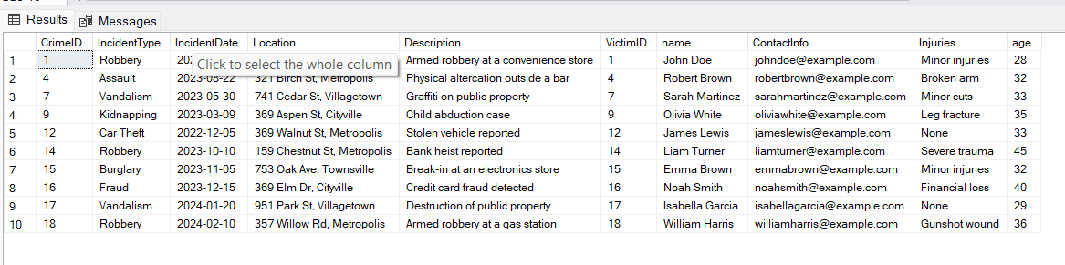

1. count(crimeid) as total_number_of_incidents from crime;

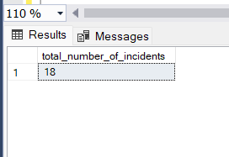

1. select distinct incidenttype from Crime;

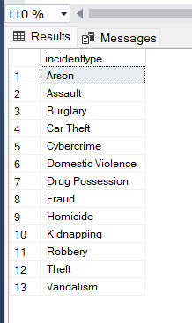

1. select * from crime where IncidentDate between '2023-09-01' and '2023-09-10';

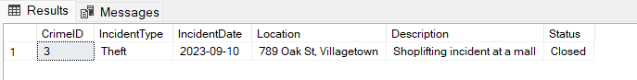

1. select * from Victim order by age desc;

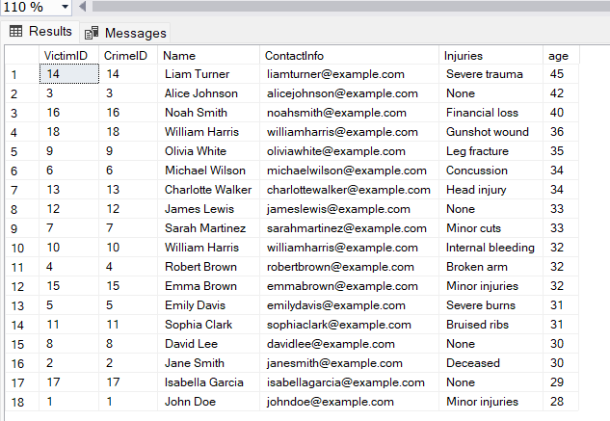

1. select injuries,avg(age) as average_Age from Victim group by Injuries;

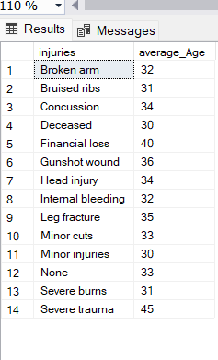

1. select incidenttype,status,count(IncidentType) as Count from Crime where status='Open' group by IncidentType,Status;

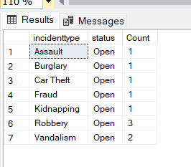

1. select * from Victim join Crime on Crime.CrimeID=Victim.VictimID where name like '%doe%';

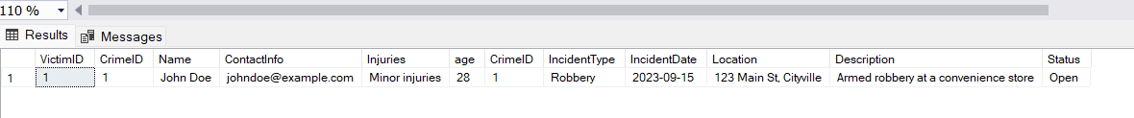

1. select v.victimid,v.name,v.contactinfo,v.injuries,v.age from victim v join Crime c on c.CrimeID=v.CrimeID where c.Status='Open';

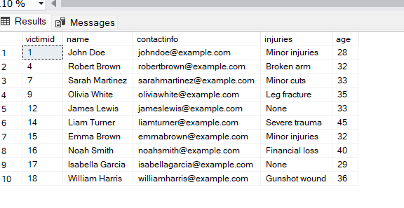

1. select v.name as victim_name,v.age,c.incidenttype from Victim v join Crime c on c.CrimeID=v.CrimeID where v.age between 30 and 35;

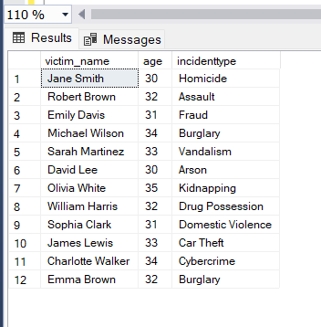

1. select c.CrimeID,c.IncidentType,c.IncidentDate,c.Location,c.Description,v.VictimID,v.name,v.ContactInfo,v.Injuries,v.age from Crime c join Victim v on c.CrimeID=v.CrimeID where IncidentType='Robbery';

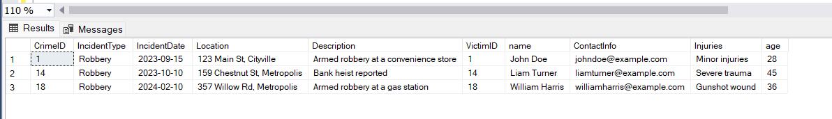

1. select incidenttype,Count(incidenttype) as Count_of_incident from crime group by IncidentType having count(incidenttype)>1;

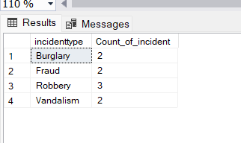

1. select * from Suspect where Name in (select name from Victim);

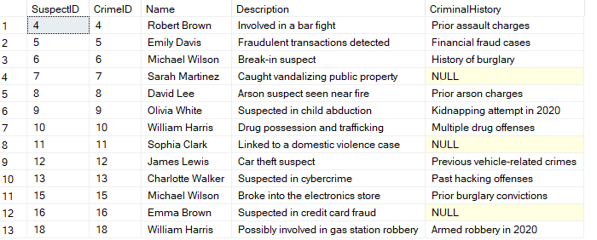

1. select c.incidenttype,c.incidentdate,c.location,c.status,v.name as victim_name,v.contactinfo,v.injuries,v.age,s.name as suspect_name,s.description,s.criminalhistory from Crime c join Victim v on v.CrimeID=c.CrimeID join Suspect s on s.CrimeID=c.CrimeID;

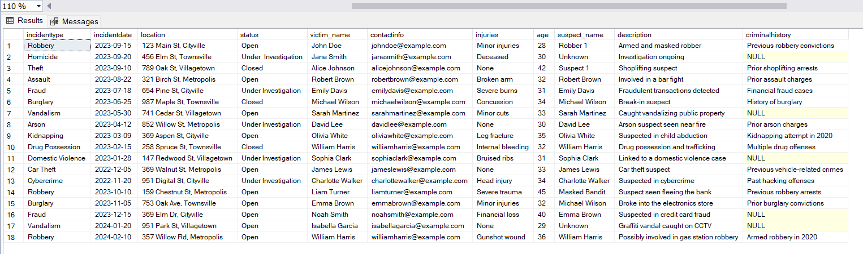

1. select s.name as suspect_name,s.age as suspect_age,v.name as victim_name,v.age as victim_age from Suspect s join Victim v on s.CrimeID=v.CrimeID where s.age>v.age;

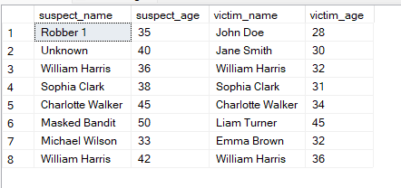

1. select Name,Description,CriminalHistory,CrimeID from suspect where name in (select name SuspectID from suspect group by name having count(name)>1) order by name;

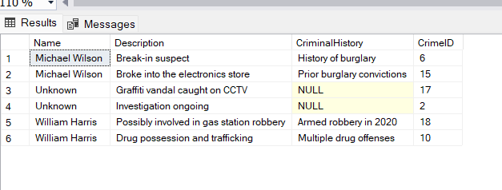

1. select * from Crime C left join Suspect S ON C.CrimeID = S.CrimeID where s.SuspectID is null;

returns empty table since every crime has an suspect associated with it so there are no null values on suspect id in suspect table

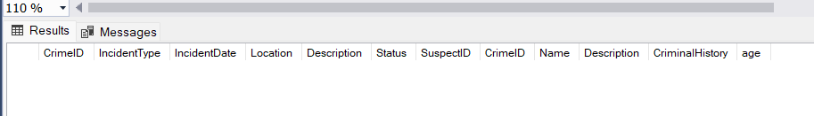

1. select CrimeID

from Crime

group by CrimeID

having count(case when IncidentType = 'Homicide' then 1 end) >= 1 and count(case when IncidentType NOT IN ('Homicide', 'Robbery') THEN 1 END) = 0;

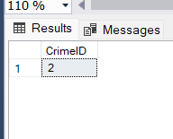

1. select c.CrimeID, c.IncidentType, c.IncidentDate, c.Location, s.Name AS SuspectName from Crime c left join Suspect s ON c.CrimeID = s.CrimeID order by c.CrimeID;

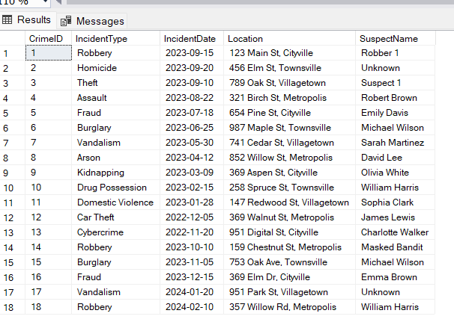

1. select s.crimeid,s.name,s.description,s.age,c.incidenttype from suspect s join Crime c on s.CrimeID=c.CrimeID where c.IncidentType='Assault' or c.IncidentType='Robbery';

